Welcome to 5th Grade!


Parent /Teacher Contacts:
Please remember that we are here to address any concerns, comments, or questions that you might have about your child’s school experience. We are best reached by e-mail at: tlyda@murrieta.k12.ca.us and clauvray@murrieta.k12.ca.us. We are also available by phone at 696-1428, however we prefer email correspondence as not all phone calls or voice messages are received.

Regular Correspondences:
*Phone calls home *emails
*Fall conferences *Before/after school visits
*Spring conferences as needed *Notes home/in agenda

Format for Instruction:
Your child will be spending half of the day with Mrs. Lauvray for Language Arts and Social Studies. He/ She will spend the other half of the day with Mrs. Lyda for Math and Science instruction. We will be participating in Physical Education with the rest of the fifth grade team. Students will receive whole class instruction, group instruction and will be working in collaborative groups. Students will be participating in note taking strategies, independence building, and character building in hopes of preparing them for middle school. Parent volunteers in the classroom are welcomed and are very helpful. See attached form.

Academic Progress:
Your child will be receiving mastery marks (1-5), for Language Arts, Math, Social Studies and Science. Marks are based on each student’s proficiency and completion of Common Core Standards. Students scoring below a 70% on an assessment must correct the assignment and have it signed by a parent in order to raise the failing assignment to a 70%.


Homework:
Homework will be a nightly routine Monday through Thursday. Your child should spend an average of 60 minutes each night to complete the assignments. It may take longer if they do not finish their work in class. Language Arts and Math homework will be given every night. Science and Social Studies homework will be given on an as needed basis. All assignments are due the following day unless otherwise specified in their Homework Binder. To earn maximum credit, homework must be turned in the next day. Late work will earn a lower score. Students will be given notice each grading period as to when make-up work and test corrections will no longer be accepted. Students who fail to turn in their daily homework will automatically lose a minimum of 10 honor points for each missing assignment. They are encouraged to bench themselves at recess until the assignment is turned in, and if it is still incomplete, they will attend the “Get ‘er Done’ room on Mondays from 1:10-1:40.

Math, Science, and Social Studies-
All assignments must be completed in the appropriate subject notebooks. These notebooks will be checked/graded periodically.

Reading – students don’t complete a formal reading log due weekly, but will have monthly-ish book reports that will be presented/graded. Although there is no log, please encourage your child to read at home daily! The benefits are amazing!

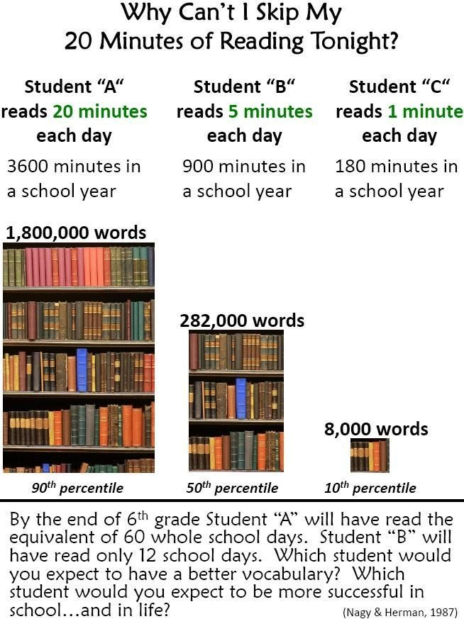


The students will participate in PE several times a week. Please remind your child to dress and wear appropriate shoes for physical activity. We will do push-ups and sit ups occasionally- if you will be wearing a skirt then please wear shorts underneath them. A student that must miss PE due to an illness/ injury will need a note. The note is good for one day only unless it is a doctor’s note. A student that is excused from PE due to an injury will not participate in a physical activity at recess. We wouldn’t want to add to the injury. Students may bring a book to read during the excused activity. If your child would like to bring a towel to sit on during PE for sit-ups and push ups, then he/she is responsible for keeping track of it.

Absent Policy: When a student is absent they will have the same number of days (+1) to make up the work. EX: Student is absent Tue. and Wed., the student would have 3 days to make up the work.

Keeping Tabs: Each child will need a 2” 3-ring binder. This assignment should already be completed the first week of school. The binder will include a Homework Agenda where all assignments are to be written down daily. For the first few weeks the teacher will check the Agenda to make sure the homework has been recorded. Each night the parent needs to look over the Homework Binder and assignments. The parent will sign it to let us know that you have seen your student’s completed homework. Math papers are graded in class the day they are due. Please monitor their progress by asking to see these each night.

Students will not be permitted to call home for missing work. If we all work on helping the students become responsible, then everyone will benefit. Please do not send in notes excusing your child from completing homework assignments. We will not excuse work for things like practice, games, parties, or extracurricular activities. We do understand family emergencies and medical situations.

Behavior Monitor:
As part of our classroom management, a Monitor system is used. As needed, a student will be given one verbal warning to improve their behavior. If that behavior continues they will be told to retrieve a Behavior Monitor, tape it on their desk and “mark their slip”. This mark will result in the loss of ten Honor Points. Should that student require another reminder they will be told to mark their slip again.

Only marked slips will be sent home on Fridays for you to see. If your child’s slip contains marks please discuss ideas for improvement. Those slips will need to be signed and returned to school the following Monday. Any slips that are not returned will result in a loss of recess until it is returned.

Cell phones and Electronic Devices at School- 
We realize that many of our students have cell phones. The teachers will enforce the district policy of prohibited cell phones turned on or out while a student is on campus. Students will need to use their phones off campus. The teachers are not responsible for keeping track of a cell phone.

Food Allergies-
We have several students in our school that may have food allergies, food sensitivities or dietary restrictions. Food allergies can trigger reactions that range from very mild to life threatening anaphylaxis). Generally, an individual must ingest a food allergen to have a reaction, but for some, even being exposed to it or ingesting a very small amount can cause a life threatening reaction. In order to minimize the occurrences of allergic reactions MVUSD policy does not allow food to be served to students without prior written approval. In observance of this district policy we ask that if you visit the Buchanan campus to share a meal with your student that you do not bring food for other students. Therefore, in celebration of your student’s birthday, he/she may bring in a goody bag (with no food items) or a non- food treat for each student in the class. Another idea is to donate a book to the classroom or school library.

All Star Day and Honor Points- 

All Star Day is a fun day designed to reward students who have been respectful and responsible for the grading period.

Students will have the opportunity to earn 20 points daily.

Points are earned in the following areas:

-student work
-class work
-complete homework
-parent signature
-citizenship--these include behavior, character counts, effort

*Honor Points do NOT carry over to the next grading period. The number of points are subject to change depending on the type of behavior. With each reporting period, the number of honor points deducted will increase.
**Scheduled All Star Days (Dates are tentative.)
October 28, December 16, March 17 and Fun Week June 5-9.
Student participation in All Star Day activities will be as follows:
80% -100% Honor Points earned will be at the park all day for activities.
70% or below of Honor Points earned will spend the day doing class work.

*** Participation in All Star Days is based on the Honor Points earned, NOT academic scores!

Schedule:
8:20am - Bell Rings
8:20-8:50 PE
8:50- 10:10 Block 1(Math or LA)
10:10-10:30 – RECESS
10:30- 12:00 – Block 2 (Math or LA)
12:00-12:30 LA UA rotations
12:30- 1:10- LUNCH
1:10-1:50 – Science or Social Studies
2-2:40 – Math UA Rotation
2:40-Dismissal

** Mondays are Early Release Days – students will be dismissed at 1:45



Curriculum Guide:

Reading: Houghton Mifflin- California Reading series, Core literature (ex. The Lion, witch, and the Wardrobe)

Language Arts: Houghton Mifflin
Language Arts: Oral Presentations
Writing Portfolios
Writing workshops Grammar Plus/Houghton Mifflin
Social Studies: Harcourt Brace

Unit studies/Projects

Simulation Activities
Chapter tests/quizzes

Mathematics: Houghton Mifflin: Go Math
Supplemented by enrichment materials
Periodic Quizzes
Tests after each chapter

Science: Mystery Science, McGraw Hill
Life Sciences
Earth and Space Science
Physical Science
Engineering, Technology and Applications of Science

How to help your child study- We all want to see the students succeed. Study habits are an important part of this.
Some things that have worked for us in the past include:
- Checking agenda every night to see assignments. If nothing is written, then the child should call a study buddy to double check.
- Language Arts, and Math will be assigned daily.
- Weekly spelling tests, vocabulary tests, reading story tests, and math test should be expected.
- All students MUST know their basic addition, subtraction, multiplication, and division facts. If your child has trouble with any of these facts, please help him/her by quizzing him/her frequently (while driving in the car, at dinner, sing the facts…. anything that will help the child to memorize them).

Please sign below, tear and return to your child’s teacher.
----------------------------------------------------------------------------

We have read the packet and understand the policies for
5th grade at Buchanan Elementary School.

Student Signature:__________________________________________

Parent Signature:__________________________________________

Date:____________________________________________________

